A CRM covering to Manage the Services offered

by an Institution

**By**

***SASANK***

[***gvsasank2003@gmail.com***](mailto:gvsasank2003@gmail.com)

# A CRM covering to Manage the Services offered by an Institution

Leading educational brass EduConsultPro Institute provides a range of programs and courses in several subjects. The institute confronts difficulties in in effect handling the admissions process, student inquiries, and professional consultation services as the number of prospective students seeking admission rises year after year. In order to overcome these obstacles, EduConsultPro Institute chooses to use Salesforce CRM to improve the entire undergo for admissions personnel and students by streamlining the admissions process.

The admissions procedure for potential students wishing to sign up for courses and programs provided by EduConsultPro Institute is the main topic of the use case. The objective is to give students a smooth and open go through while allowing admissions staff to examine quickly and handle student inquiries, case management, and admission diligence.

## Index

|  |  |
| --- | --- |
| ***S.No.*** | ***Modules*** |
| 1. | Requirements |
| 2. | Create Objects from Spreadsheet |
| 3. | Create a ScreenFlow for Student Admission Application process. |
| 4. | Create Users |
| 5. | Create an Approval Process for Property Object |
| 6. | Create a Record Triggered Flow |
| 7. | Create a ScreenFlow for Existing Student to Book an Appointment |
| 8. | Create a ScreenFlow to Combine all the flows at one place |
| 9. | Create a lightning app page |

**Requirements**

### *Admission Application Management:*

The institute's website or portal should provide prospective students with access to the admission coating form. A thorough set of data, including personal and Danish history, reservation, and personal details, should be gathered for the entrance application. diligence for admission that have been submitted ought to be recorded and kept in the Salesforce CRM database. Upon successfully submitting their diligence, students ought to receive automated email notice. It should be possible for admissions personnel to create dashboards and reports that examine trends in enrollment, acceptance rates, and applicant metrics.

### *Approval Process Requirements:*

To measure and approve consulting requests, implement an approval process in Salesforce. Configure an email display to inform pertinent students of their approval or rejection. Ensure that as soon as a request is created, it is automatically sent.

### *Management of audience Services:*

Through the institute's website or portal, prospective students ought to be able to make requests for audience services. The student's info, preferred consultation areas, and requisite areas of expertise should all be recorded in the consulting request form. Consulting requests that have been submitted ought to be noted in the Salesforce CRM system. It should be automated for advisors and consultants to receive email telling when new consultation requests are made. Within the Salesforce CRM interface, consultants should be able to view, accept, and handle audience requests. Salesforce should allow for the scheduling of consulting appointments, including the appointment's date, time, and goal. It is important to monitor and change appointment statuses (such as planned, finished, or canceled) in Salesforce.

### *Immigration Case Management:*

Students should be able to beginner immigration cases through the phone, email or web. Relevant data and case specifics should be recorded in the immigration case submission form. Immigration cases that are submitted ought to be tracked down and kept in the Salesforce CRM database. New immigration cases should be automatically notified by email to case managers and immigration agents. Immigration agents should be able to use the Salesforce CRM interface to see, handle, and monitor immigration cases. Tracking and updating case status (such as open, in process, and closed) in Salesforce is recommended.

## Create Objects from Spreadsheet

The Lightning Object Creator is a tool that makes it easier to create custom objects in Salesforce from spreadsheets. Here is a detailed tutorial on how to accomplish that.

How to Make Personalized Items from a Spreadsheet:

### *Create Course object*

* + Select "create object from spreadsheet" in your object manager.
  + To obtain the spreadsheet, Course, click the provided link.
  + Once the file has been downloaded, upload it, map the fields, and then submit it to create an object.

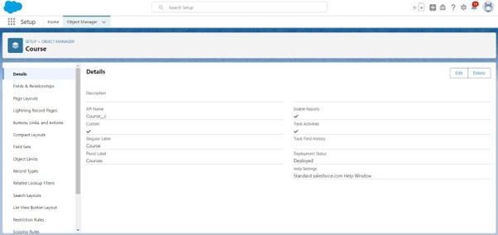

### *Produce the remaining objects.*

* + Take the same actions that we did to create the course object. For the remaining items, use the following sheets.
    1. Consultant
    2. Learner
    3. Scheduling

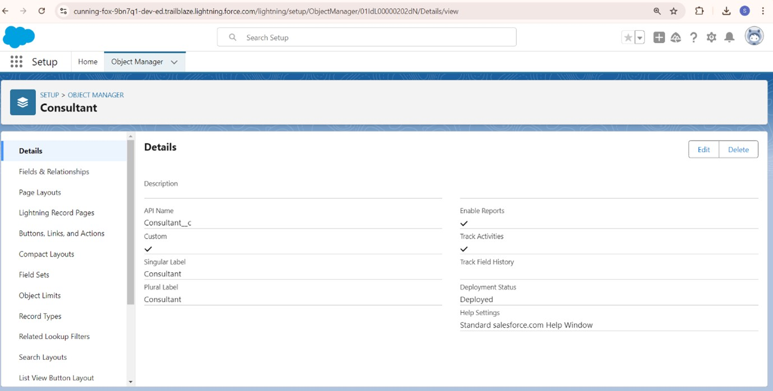

### *Make connections between the items*

1. Make a lookup table for appointments with consultants and students.
2. Make an object called Registration to hold the student and course information.
3. Establish a lookup function between the student and the case in order to store the student's immigration or visa application queries.
4. 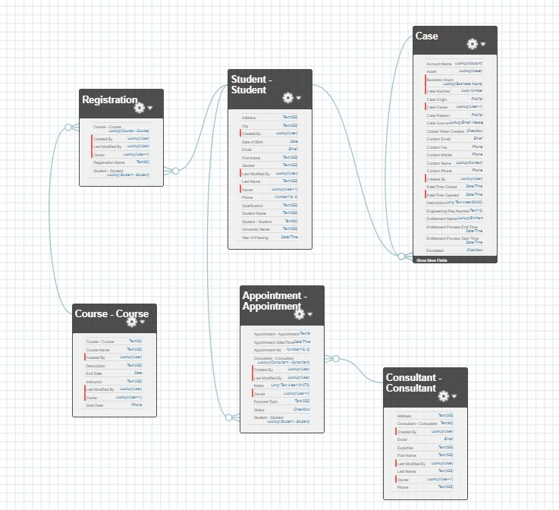The data model ought to resemble the field-and relationship-filled data model below:
5. Make tabs for the corresponding object.

### *Set Up the Case Object*

1. Go to object manager, edit case object.
2. Select the “Type” field and add the values in it. Immigration

Visa Application

1. Now Select the “Status” field and add the values in it. Open

In-progress

### *Create a Lightning App*

1. Navigate to Setup and use Quick Find to look for the App Manager.
2. Select "New Lightning App."
3. Enter "EduConsultPro" as the app name, then click Next, Next, Next.
4. From the Available Items to the Selected Items, add Home, Students, Courses, Consultants, Appointments, Registrations, and Cases.
5. After selecting the "System Administrator" profile from the list of available profiles, click Save & Finish.

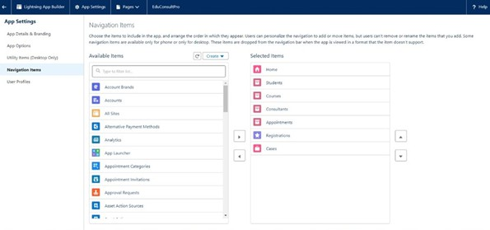

## Create a ScreenFlow for Student Admission Application process.

### *Add Screen Element From Setup:*

* 1. Quickly locate Flow Builder, then choose New Flow -> ScreenFlow.
  2. Include a Screen component.
  3. Enter "Student Info" for Label in the Screen Properties pane.
  4. To see every field that is part of the student object, click Fields, then select the record variable input and create a new resource called StudentRecordRes. Drag and drop any field that has to be added to the screen in order to gather student data.

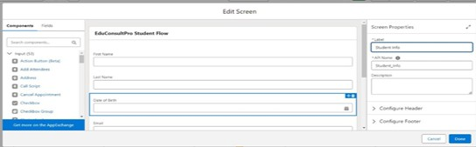

### *Create an element to create a student record.*

* 1. Place a Create element with the label "Create Student Record" after the Student Info Screen Element.
  2. Choose "use all values from a record" under How to Set the record fields and "one" under How many records to create.
  3. In the Student Info screen element, select the record variable resource (StudentRecordRes) that we created under Create a record from these values.

### *Insert Screen Feature*

* 1. Once the student record element has been created, add a screen element and name it "course screen."
  2. Create a picklist element from the left side panel, name it "Select Course," type "IELTS" into the options, then hit Enter. The variable "IELTS" is created as a result.
  3. Do the same with the GMAT, TOEFL, Duolingo, and GRE.

### *Add Decision Element*

* 1. Add a Decision Element after Select Course Screen Element, label it as Selecting Course.
  2. Under outcome label it as “Selected IELTS” and write the condition such as below: Resource : Select_Course (Screen Component from Select Course Screen Element) Operator : Equals Value : IELTS (Choice Variable from Select Course Screen Element)
  3. Click on the “+” icon and Repeat step 2 for other options mentioned as below: GRE

GMAT

DuoLingo TOEFL

Click Done.

### *Add GET Record Element*

* 1. Add a GET Record Element after Decision Element, under the IELTS path and label it as “Get IELTS Rec”.
  2. Select Object : Course

Condition Requirement : All Conditions are Met(AND)

* 1. Field : Course Name Operator : Equals Value : {!Select_Course
  2. Repeat the steps 1 & 2 for the GRE, GMAT, TOEFL, DuoLingo paths.

### *Create Registration Record using Create Records Element*

* 1. Add a Create element after the Get IELTS Rec element and label it as “Create IELTS Registration Rec”.
  2. Select “one” under How many records to Create, and select “Use separate resources, and literal values” under How to Set the record fields.
  3. Select Object : Registration
  4. Field : Course_Name c Value : {!Get_IELTS_Rec.Id}
  5. Field : Student_Name c Value : {!StudentRecordRes.Id}
  6. Repeat the steps 1 & 2 for the GRE, GMAT, TOEFL, DuoLingo paths.

### *Create Email Text Template Variables for email body and subject*

* 1. Click on the toggle toolbox on the left corner, click “New Resource”, then select “Text Template” as Resource Type.
  2. Give the API name as “StuRegistrationEmailTextTempBody”, select “view as plain text” and paste the below text in body.

“Dear {!StudentRecordRes.Name},

Congratulations and welcome to EduConsultantPro!

We are delighted to inform you that your registration on our platform has been successfully completed. You are now part of our esteemed community dedicated to empowering students like you to achieve their educational and immigration aspirations.

At EduConsultantPro, we understand the importance of your academic and career goals, and we are committed to providing you with the highest level of support and guidance throughout your journey.

Here are a few key points to help you get started:

Explore Our Resources : Take some time to explore the wide range of resources, tools, and services available on the EduConsultantPro platform. From educational insights to immigration advice, we offer comprehensive support tailored to your needs.

Connect with Our Consultants : Our team of experienced consultants is here to assist you at every stage of your educational and immigration endeavors. Don't hesitate to reach out to us with any questions, concerns, or inquiries you may have. We're here to help!

Stay Updated : Keep an eye on your inbox for important updates, announcements, and exclusive opportunities from EduConsultantPro. We'll ensure that you're informed about the latest developments and relevant information to support your journey.

Engage with the Community : Join our vibrant community of students, professionals, and experts who share your passion for education and global opportunities. Connect with like- minded individuals, participate in discussions, and expand your network.

Once again, congratulations on taking this important step towards realizing your academic and career aspirations. We are thrilled to have you as part of the EduConsultantPro family and look forward to supporting you on your journey to success.

If you have any questions or need assistance, please don't hesitate to contact us.

Thank you.” Click Done.

* 1. Repeat steps 1 & 2 to create an email text template for the email subject, label it as

“StuRegistrationEmailTextTempSub”, write a text message in the body and save it.

### *Add an Action Element*

1. Add an Action Element after all the Decision paths, label it as “Send Email to

Student”.

1. Under “Set input values for selected action”, include body, Recipient Address List and Subject.
2. For input Body : {!StuRegistrationEmailTextTempBody}, Recipient Address List : {!StudentRecordRes.Email c}, Subject : {!StuRegistrationEmailTextTempSub}.

Add Screen Element

1. Add a Screen Element after the Send Email to Student Action Element, label it as Success Screen.
2. From the left side panel search for the Display text component and drag it to the main panel, label it as “SuccessMessage”.
3. Paste the below in the Resource picker box.

“Dear {!StudentRecordRes.Name},

Congratulations and welcome to EduConsultantPro!

We are delighted to inform you that your registration on our platform has been successfully completed. You are now part of our esteemed community dedicated to empowering students like you to achieve their educational and immigration aspirations. Your Registration details have been sent through mail kindly check it once.

Thank you.”

1. Click Done.
2. Save the flow and name it as “EduConsultPro Student Flow”. Your flow will look as shown below:

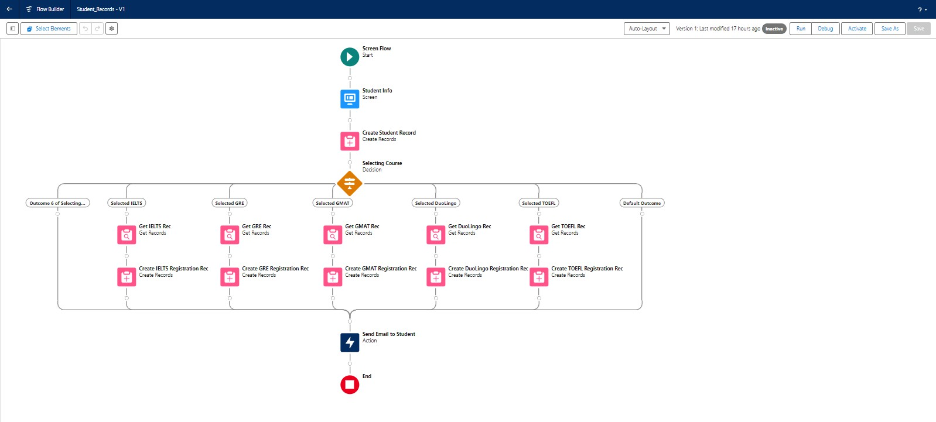

# Create Users

Make a user with the user profile of the Standard platform.

## User

1. Go to Setup --> Administration --> Users --> New User
2. LastName : Consultant
3. License : Salesforce Platform
4. Profile : Standard Platform User
5. Fill all the mandatory fields & Save.

## Configure the User Settings

1. Go to Setup --> Administration --> Users --> click Edit next to your name
2. Scroll down to bottom, under Approver Settings, Select “Consultant” the Manager Field.
3. Click Save.

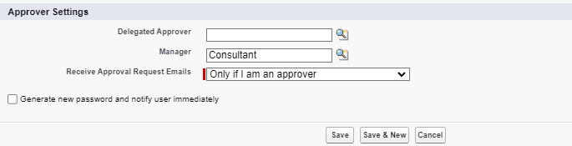

# Create an Approval Process for Property Object

### *Create an Email Template*

* 1. From Setup, enter Templates in the Quick Find box, and then select Lightning Email Templates, toggle on.

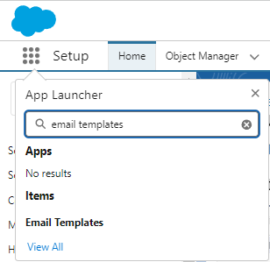

* 1. go to app launcher, search for “Email Templates”, Create a new folder with the desired name.
  2. Then create a new email template, select the folder which we have created in the previous steps, enter the below text in the HTML Value and Save it as "Submission Template".

"Dear {{{Appointment c.Student_Name c}}},

I hope this email finds you well. I am writing to confirm the details of our upcoming appointment scheduled for {{{Appointment c.Appointment_DateTime c}}} regarding

{{{Appointment c.PurposeTopic c}}}. Appointment Details:

Appointment No : {{{Appointment c.Name}}},

Student Name : {{{Appointment c.Student_Name c}}}, Consultant Name : {{{Appointment c.Consultant c}}},

Date & Time : {{{Appointment c.Appointment_DateTime c}}}, Purpose : {{{Appointment c.PurposeTopic c}}}

I want to assure you that I am looking forward to our meeting and am fully prepared to address any questions or concerns you may have regarding

{{{Appointment c.PurposeTopic c}}}. Your success and satisfaction are my top priorities, and I am committed to providing you with the guidance and support you need. If you have any specific topics or questions you would like to discuss during our appointment, please feel free to share them with me in advance. This will help ensure that our time together is as productive and beneficial as possible.

If for any reason you need to reschedule or cancel our appointment, please notify me at your earliest convenience so that we can make alternative arrangements.

Once again, thank you for choosing to work with me on this matter. I am confident that our collaboration will lead to positive outcomes and progress toward your goals.

If you have any questions or require further information before our scheduled appointment, please don't hesitate to reach out to me.

Looking forward to our meeting. Best regards,

{{{Recipient.Name}}}, EduConsultantPro"

* 1. Create two more Email templates for Approval and Rejection of Request similar to the previous one.



### *Create an Approval Process*

* 1. From Setup, enter Approval in the Quick Find box, and then select Approval Processes.
  2. In Manage Approval Processes For, select Appointment.
  3. Click Create New Approval Process --> Use Jump Start Wizard.
  4. Configure the approval process.
  5. Process Name - Appointment Approval, Under Select Approver, Select Manager for the option : “Automatically assign an approver using a standard or custom hierarchy field.”
  6. Click next and “Next Automated Approver Determined By” --> Select Manager.
  7. From Record Editability Properties --> Click on Administrators OR the currently assigned approver can edit records during the approval process.
  8. Save the approval process.
  9. Click View Approval Process Detail Page.
  10. Under Initial Submission Actions, click Add New --> Field Update, and configure it with these values.

|  |  |
| --- | --- |
| **Field** | **Value** |
| Name | Submitted |
| Field to Update | Appointment: Status |
| A Specific value | Pending |

* 1. click Add New --> Email Alert, and configure it with these values. Description : Submission Email Alert

Unique Name : Auto Populates

Email Template : Submission Template Recipient Type : Select your Name

* 1. Repeat the Steps 10 - 11 for Final Approval and Final Rejection actions.

# Create a Record Triggered Flow

### *Conﬁgure the Start Element*

* 1. From Setup, enter Flows in the Quick Find box, then select Flows.
  2. Click New Flow.
  3. Select Record-Triggered Flow.
  4. Click Create. The Configure Start window opens.
  5. For Object, select Appointment.
  6. For Trigger the Flow When, select A record is created. The flow will look like this:

### *Add an Action Element*

* 1. Add an Action element after the Start Element and Select the Submit for approval action, label it as “Approval SubFlow”.
  2. Set the RecordId to “{!$Record.Id}”.

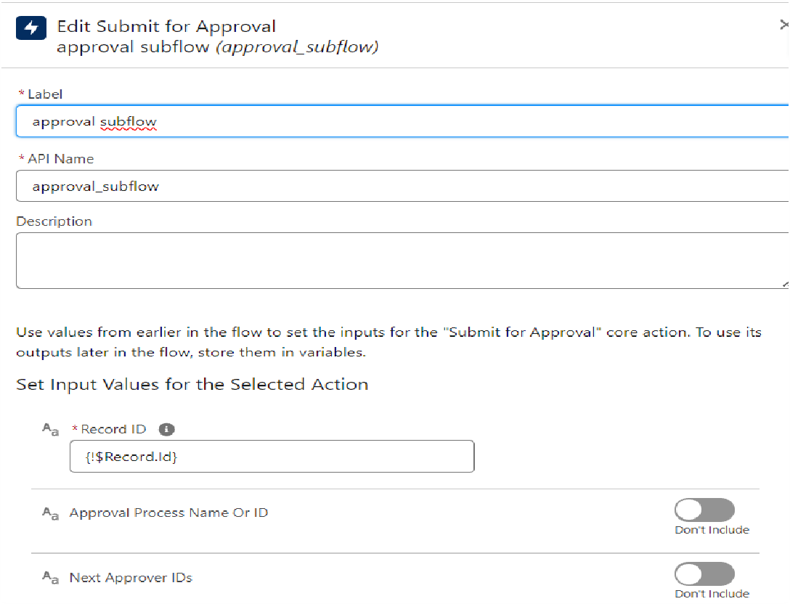

* 1. Save the Flow, label it as "EduConsultPro Approval Flow and Click on Activate.

# Create a ScreenFlow for Existing Student to Book an Appointment

### *Add Screen Element*

* 1. From Setup, enter Flow Builder in quick find, select new flow ? ScreenFlow.
  2. Add a Screen element.
  3. In the Screen Properties pane, for Label, enter “Get Student Info”.
  4. Add two Text components from the left side panel. Give the Label’s as follows: 1st Text Component Label : Enter Student Name

2nd Text Component Label : Enter Student Email

### *Add GET Record Element*

* 1. Add a GET Record Element after Decision Element, under the IELTS path and label it as “Get Rec”.
  2. Select Object : Student

Condition Requirement : All Conditions are Met(AND)

* 1. Field : Student Name Operator : Equals

Value : {!Enter_Student_Name}

* 1. Field : Email c Operator : Equals

Value : {!Enter_Student_Email}

### *Add Decision Element*

* 1. Add a Decision Element after Select Display Student Details Element, label it as “Appointment or Case”.
  2. Under outcome label it as “Appointment” and write the condition such as below: Resource : {!How_may_I_Help_you}

Operator : Equals

Value : {!Book_an_Appointment}

* 1. Click on the “+” icon and Repeat step 2 for Case options mentioned.
  2. Click on done.

### *Add Screen Element*

* 1. Add a Screen element after the Decision Element, on the Appointment path and label it as “Appointment Booking Screen".
  2. Click on Fields, click on the record variable input and create a new Resource

(AppointmentRecordRes) to display all the fields which are in the Appointment object.

* 1. Drag all the fields which are needed to add on the screen inorder to collect the student information.

### *Add GET Record Element*

* 1. Add a GET Record Element after Decision Element, under the Appointment path and label it as “Get Consultant Rec”.
  2. Select Object : Consultant

Condition Requirement : All Conditions are Met(AND)

* 1. Field : Name Operator : Equals

Value : {!AppointmentRecordRes.Consultant_Name c}

### *Create Appointment Record using Create Records Element*

* 1. Add a Create element after the Get Consultant Rec element and label it as “Create Appointment”.
  2. Select “one” under How many records to Create, and select “Use separate resources, and literal values” under How to Set the record fields.
  3. Select Object : Appointment
  4. Field : Appointment_DateTime c

Value : {!AppointmentRecordRes.Appointment_DateTime c}

* 1. Field : Consultant c

Value : {!Get_Consultant_Rec.Id}

* 1. Field : Notes c

Value : {!AppointmentRecordRes.Notes c}

* 1. Field : PurposeTopic c

Value : {!AppointmentRecordRes.PurposeTopic c}

* 1. Field : Student_Name c Value : {!Get_Rec.Id}

### *Add Screen Element*

* 1. Add a Screen Element after the Send Email to Student Action Element, label it as “Confirmation Screen”.
  2. From the left side panel search for the Display text component and drag it to the main panel, label it as “Appointment_Confirmation”.
  3. Paste the below in the Resource picker box.
  4. Consultant Name : {!Get_Consultant_Rec.Name},
  5. Date & Time : {!AppointmentRecordRes.Appointment_DateTime c},
  6. Notes : {!AppointmentRecordRes.Notes c},
  7. Click Done.

### *Add an SubFlow Element*

* 1. Add a subflow element after the Decision Element, on the Case path and search and Select for “Create a Case”, label it as “Create Student Case”.
  2. Save the flow and label it as “EduConsultantPro Existing Student Flow”, you can use the below image for reference.

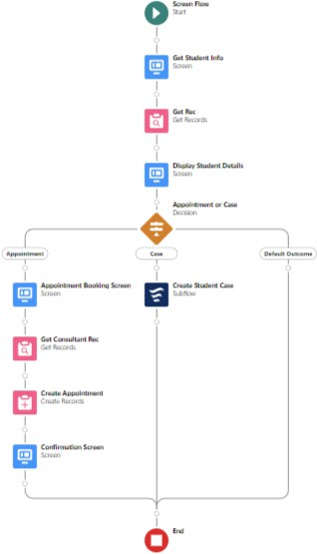

# Create a ScreenFlow to Combine all the flows at one place

### *Add Screen Element*

* 1. Add a Screen Element and label it as Welcome Screen.
  2. From the left side panel search for the Display text component and drag it to the main panel, label it as “SuccessMessage”.
  3. Paste the below in the Resource picker box.

“Welcome to EduConsultantPro

your premier destination for education and immigration solutions!

At EduConsultantPro, we understand that embarking on educational or immigration journeys can be both exhilarating and daunting. That's why we're here to guide you every step of the way with expertise, dedication, and personalized support.

Whether you're seeking to pursue your academic dreams abroad, navigate the complexities of immigration processes, or enhance your professional skills through international opportunities, EduConsultantPro is your trusted partner.

Our team of seasoned consultants is committed to understanding your unique aspirations and crafting tailored strategies to help you achieve your goals efficiently and effectively.

From selecting the right educational institution to navigating visa procedures, our comprehensive services cover all aspects of your journey.

At EduConsultantPro, we believe in fostering inclusive communities and unlocking the full potential of every individual. With our unwavering commitment to excellence and integrity, we strive to make your experience with us seamless and rewarding.

Welcome to EduConsultantPro – where your aspirations meet our expertise, and together, we pave the path to success. Let's embark on this transformative journey together!”

* 1. Click Done.

### *Add Screen Element*

* 1. Add a Screen Element after the Welcome Screen Element, label it as “Existing or New Student Confirmation Screen”.
  2. Add a radio button component from the left side panel, label : Are you a Existing Student
  3. Click on Add Choice --> type “Yes” in the input field --> click Create Yes choice.
  4. Repeat step 6 and create an “No” choice resource.
  5. Click Done.

### *Add Decision Element*

* 1. Add a Decision Element after Existing or New Student Confirmation Screen Element, label it as “Decision 1”.
  2. Under outcome label it as “If Existing Student” and write the condition such as below: Resource : {!Are_you_a_Existing_Student}

Operator : Equals Value : {!Yes}

* 1. Click on the “+” icon and Repeat step 2 for No options mentioned.

### *Add an SubFlow Element*

* 1. Add a subflow element after the Decision 1 Element on the if Existing Student path and search and Select for “EduConsultantPro Existing Student Flow '', label it as “Existing Student Flow”.
  2. Save the flow and label it as “EduConsultantPro Existing Student Flow”.
  3. Click Done.

### *Add an SubFlow Element*

* 1. Add a subflow element after the Decision 1 Element on the if Not an Existing Student path and search and Select for “EduConsultantPro Student Flow '', label it as “New Student Flow”.
  2. Save the flow and label it as “EduConsultantPro Existing Student Flow”.
  3. Click Done.
  4. Save the flow and label it as “EduConsultPro Flow”, you can use the below image for reference.

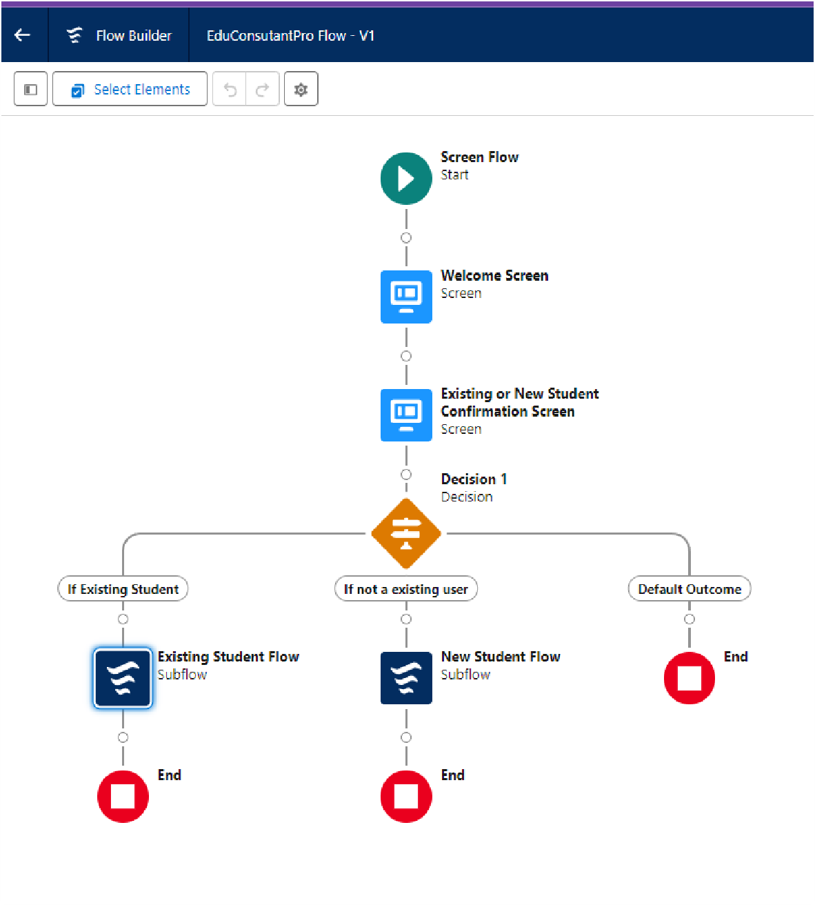

# Create a lightning app page

### *Create a lightning app page and make it available at the application*

1. From Setup, enter App Builder in the Quick Find box, then click Lightning App Builder.
2. Click New, select Home Page, then click Next.
3. Step through the wizard and name the page “EduConsultPro Home Page”, select the Standard Home Page template, and then click Done.
4. Drag the Flow component to the top-right region.
5. Search for the “EduConsultantPro Flow” and click Save.

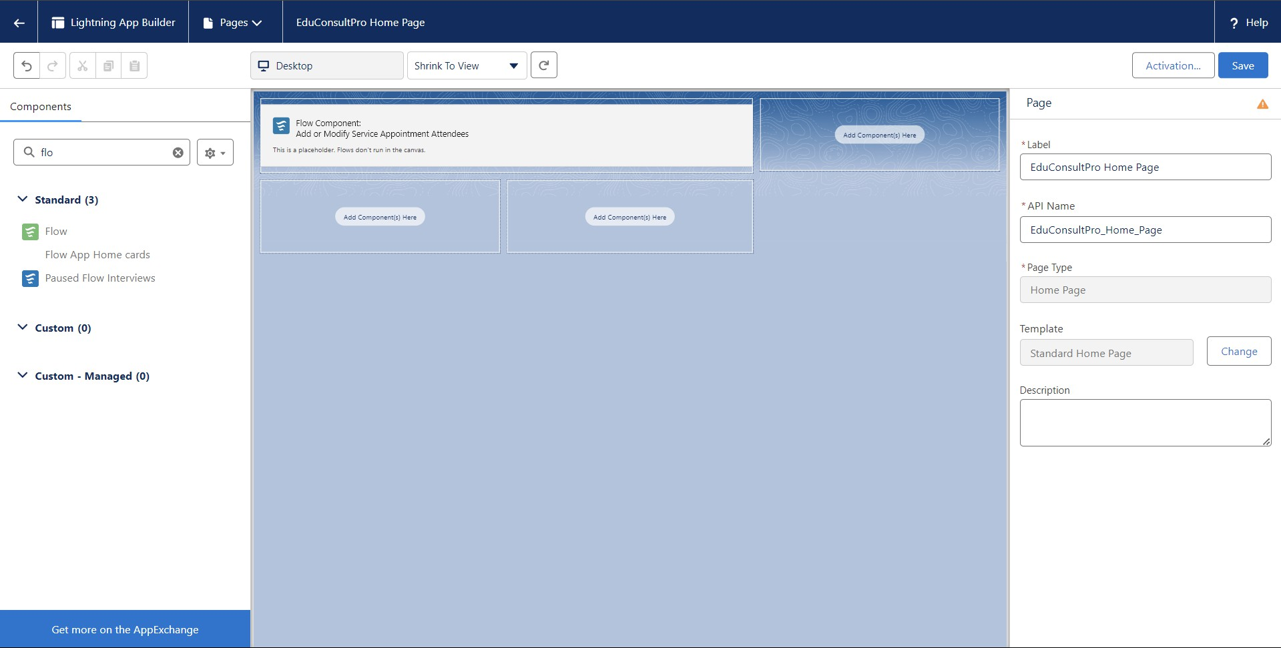

1. Click Activate, Click App and Profile, then click Assign to Apps and Profiles.
2. Select the Sales app, then click Next.
3. Scroll down the list of profiles and select System Administrator, then click Next.
4. Review the assignment, and then click Save.